(Approx. 959 words)

Another Useful Control Panel (System)
Written by Phil Sorrentino, President, Sarasota PCUG, Florida
www.spcug.org
president (at) spcug.org

This article has been obtained from APCUG with the author’s permission for publication by APCUG member groups; all other uses require the permission of the author (see e-mail address above).

In an earlier edition of the Monitor, July 2009, we discussed what control panels are, and looked at the “Folder Options” control panel in detail. As we said in that article, “The Windows Control Panel is the component of the Windows User Interface that allows users to modify and personalize the way Windows (XP and Vista) operates. All of the User Interface settings and controls that are under user control can be manipulated by the small applications (called applets) that are part of the Windows Control Panel.” The “System” control panel is another of these very useful applets. It provides basic information about the hardware, the software, the device drivers, and how the computer operates in a network. The information provided under XP and Vista is similar, but the displays are different.

There are a few basic things that every user should know about the computer they are using. Some of these are: what CPU (Central Processing Unit) is the computer built around; how much RAM (Random Access Memory) is installed; what OS (Operating System) is being used and what OS Service Pack is installed, if any; what is the computer’s name; how many hard drives are installed; and how much space is available on each hard drive. The “System” control panel provides the answers to the first 4 of these questions. (The hard drive information can be obtained by double-clicking My Computer, or Computer in Vista, and looking at the properties of the hard drive by right-clicking the hard drive of interest and selecting properties.)

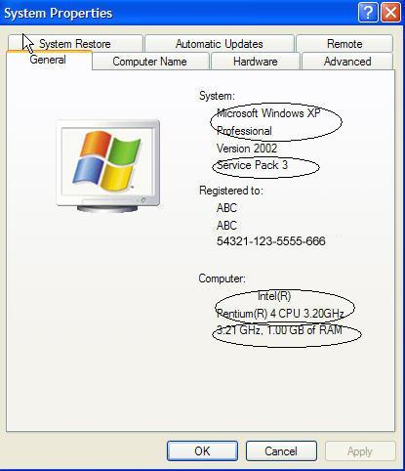
To get to the System control panel on an XP machine, on the taskbar click start, then click on Control Panel, then double-click on the System icon. This will display the System Properties window.

The CPU, RAM, OS and Service Pack can be seen on the System Control Panel-General tab, as shown in the following:

In this XP example, the CPU is an Intel Pentium 4 (running at a clock speed of 3.2 GHz), there is 1 GB of RAM installed, and the OS is Microsoft Windows XP Professional with Service Pack 3 installed.

Computers that are part of a home network must have a name, a description, and be part of a Workgroup. The Computer Name is used to find data located on computers on a network. The workgroup indicates which other computers can potentially share data with this computer. In XP, this information is obtained from the System Control Panel-System Properties-Computer Name tab as shown in the following:

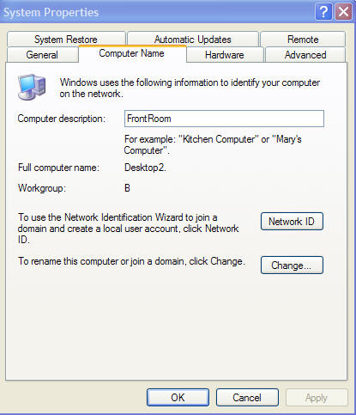
In this XP example, the Computer’s (network) name is “Desktop2”, its description is “FrontRoom” (which is also its location), and it is part of the “B” workgroup. Changes to the computer name and workgroup can be accomplished by clicking the “Change…” button.

The Vista System Control Panel also provides the same type of information. To get to the System control panel, on the taskbar click start, then click on Control Panel, then on the left click on “Classic View” (if it is not already in classic view), and finally double-click on the System icon. This will display a window for you to “View basic information about your computer”. The System Properties window can be displayed by clicking on the “Advanced system settings” link in the list of Tasks, to the left side of the “View basic information about your computer” window. This window is as follows:

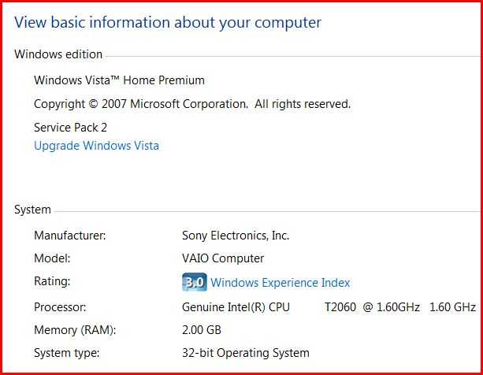

In this Vista example, the CPU is an Intel T2060 processor (running at a clock speed of 1.6 GHz), there are 2 GB of RAM installed, and the OS is Microsoft Windows Vista Home Premium with Service Pack 2 installed. In Vista, there are some additional pieces of information. The System type: shown here indicates that this machine is using a 32 bit OS (Operating Systems today are either 32 bit or 64 bit). The Rating: shows a “3.0 Windows Experience Index”. The “Windows Experience Index” is a measure of the capability of your computer's hardware and software configuration and is expressed as a number between 1 and 5.9. A higher number generally means that your computer will perform better and faster than a computer with a lower number, especially when performing more resource intensive tasks.

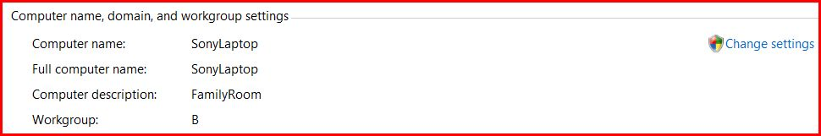

And in this Vista example, the Computer’s (network) name is “SonyLaptop”, its description is “FamilyRoom” (which is also its location), and it is part of the “B” workgroup. Changes to the computer name and workgroup can be accomplished by clicking the “change settings” link.

The System Control Panel also provides access to the “Device Manager”. This is where you can get detailed technical information about all of the hardware “devices” that are installed on your computer and allows you to install and update the software “drivers” that are associated with the hardware. (CAUTION-Be very careful in this area. Changes here can cause unintended consequences and possibly severely disable your computer.) This is an area that is probably best left to the technically inclined. However, if you are having problems with specific devices, the device status may be of help. Status Icons are shown for devices that are questionable (yellow), or not operating (red). The device properties may also be helpful and are displayed by a right-click on the specific device in the list and then selecting “properties”. The System control panel provides a lot of information, most of which you do not regularly need, but when you do need that kind of technical information it is nice to know where it can be found.

